# Website Planning:

## Pre-planning:

Simple sketch of what our site will look like:

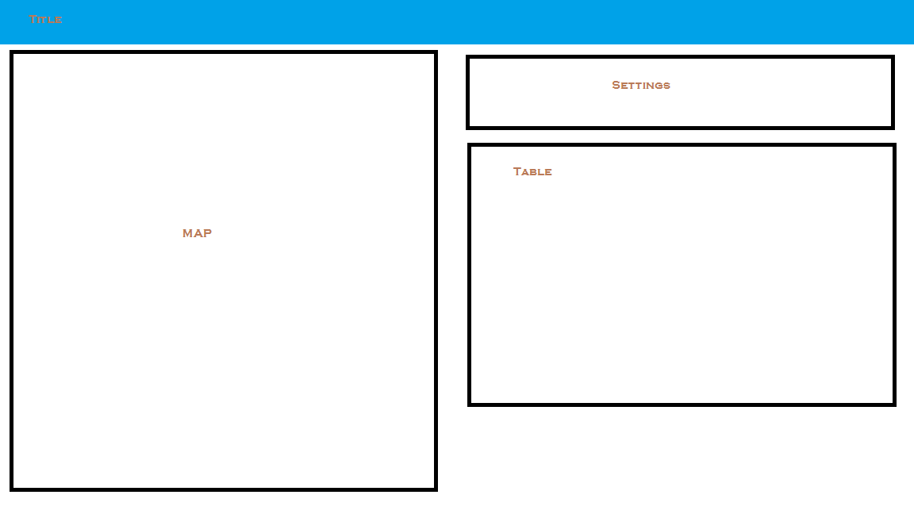

Using a framework tool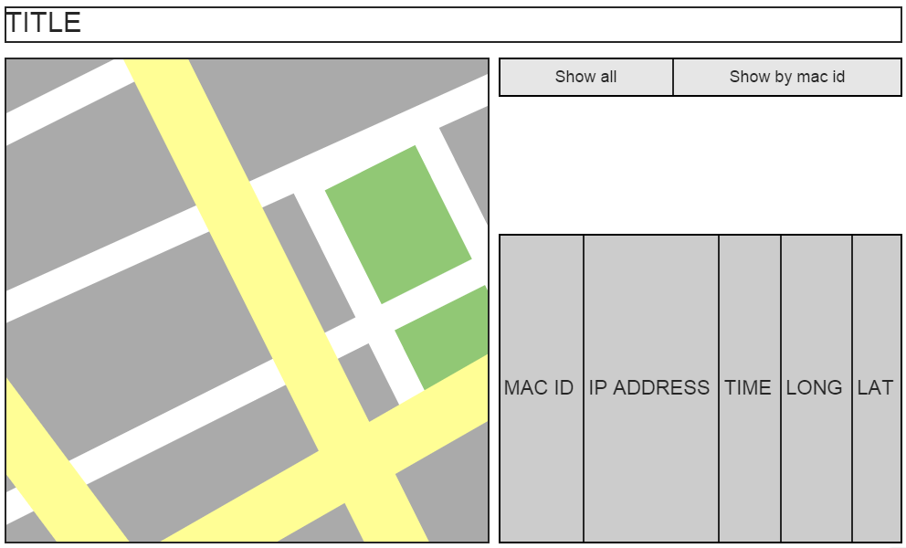

# Psuedocode

## Index.html:

Header

Import js

Import css stuff

Body

Title cssed with banner

Left div

Map

Right div

Setting buttons

Table

## Gmaps.js

Function initialize

Create google map

Set center to BCIT

TableHeaders()

mostRecentMarkers()

Function loadXMLDoc (filename)

Use XMLHttpRequest to load the file in

Return response xml

Function makeTableRow(…)

Generate a row with the data from parameter

Function makeTablehead()

Generate the header table with labels

Function refresh()

RemoveMarkers()

If mode is “all current”

mostRecentMarkers()

else

macHistoryMarkers(mode)

Function removeMarkers()

Delete rows from table

Go through array of current markers and remove markers

Function mostRecentMarkers

loadXmlDoc( coordinates.xml )

loop through all xml elements

if it’s a new mac id

add to array

if it’s an existing mac id

override old entry

loop through array

create markers

push markers to markerArray

makeTableRow()

Function macHistoryMarkers(givenMac)

loadXmlDoc( coordinates.xml )

loop through all xml elements

if xml’s mac id is equal to givenMac

create marker

push marker to marker array

make table row

Function allCurrent()

Set mode to all Current

Refresh()

Function singleMacHistory

Get text from textbox, set mode to text

Refresh()

Function refreshOn()

Set interval to call refresh()

Function refreshOff()

Remove interval to call refresh()

# Bonus: Server Configuration

For this assignment, we have had Alex setup the website and server on a raspberry pi.

* <http://lamckalex.ddns.net/GPSAssign/>
* Login: dcomm
* Password: bcit

The configuration was as follows:

* Setup SSH
* Setup apache
* Setup .htaccess and .htpasswd

Setup Port Forwarding:

* Port ??? was forwarded for ssh.
* Port 80 was forwarded for the website
* Port 7000 was forwarded for the server
* 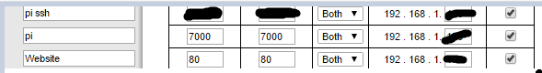

To solve the issue with the IP being possible changed

* We have setup a domain with No-IP
* No-IP is a free service that can be installed onto the raspberry pi, it will provide updates to the server with its IP Address, and this allows the website to know what the correct IP for the server is even if the ISP decides to change the IP for the Raspberry Pi.

The server was then compiled on the Raspberry Pi and it is not running 24/7.

* 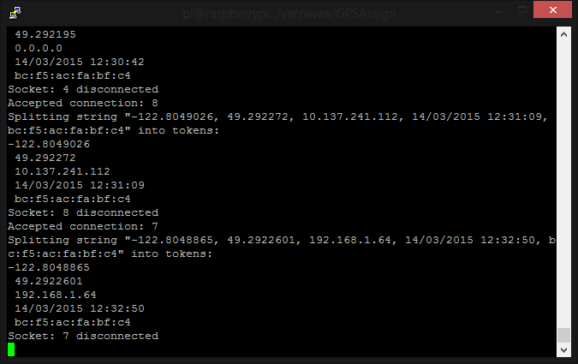

Resources:

<http://www.instructables.com/id/Host-your-website-on-Raspberry-pi/?ALLSTEPS>

<http://httpd.apache.org/docs/2.2/howto/auth.html>